Full Product Name: Weego Jump Starter 66
Model Name: 66
Model #: N66
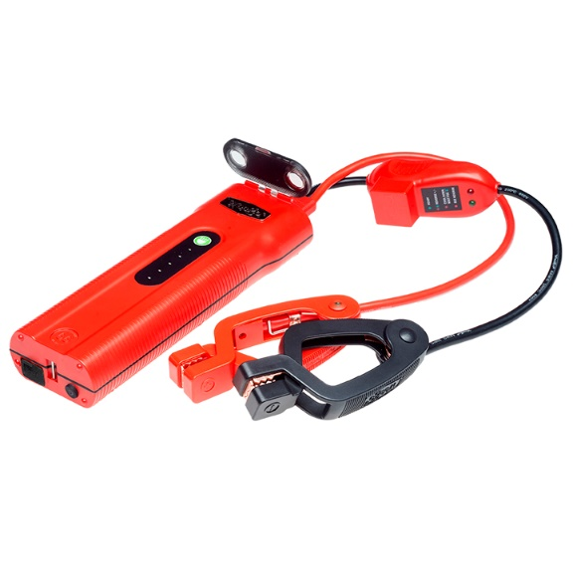
For more images, click HERE

Product Description:
When you are looking for the most powerful, Weego Jump Starter 66 is your answer. Weego 66 jump starts gas engines up to 10L (and diesel up to 5L). We're talking BIG engines! But still extremely compact. This all-in-one powerhouse can do way more. Weego 66 fast charges phones, tablets and laptops, powers 12V accessories and lights your way with a tactical, pro-grade, built-in flashlight. It's not just for emergencies; you can use it every day! Safe and simple, patented Smarty Clamps® ensure that you can't make a mistake. No experience required! Built to perform with durable, premium-quality components and an IP65 certification that means you can use it in surf and turf. Staying power? Get 1000 charging cycles and up to 3-years of standby power on a single charge. Award-winning, USA-designed and engineered, independently lab tested, verified specs (super important with portable jump starters), and hundreds of prestigious publication reviews are your assurance that Weego is the way to go!
- Starts car, truck, boat, motorcycle, ATV gas engines up to 10L (diesel up to 5L)
- Patented, foolproof Smarty Clamps® have comprehensive safety protections built in plus lights and sounds to guide you through a safe and simple jump every time
  - An extra-wide opening and power on both sides of the jaws guarantee a successful connection
  - Ergonomic grips and extra-long cables ensure easier access to hard-to-reach battery terminals
- Detect-o-Matic™ USB charger automatically provides fastest charge to your phones and tablets
- 12V and 19V outputs to power accessories and charge laptops
- Pro-grade 600-lumen LED flashlight illuminates up to 15 hours and strobe and SOS modes that last up to 30 hours on a single charge
- Hook and lanyard suspends Weego from a vehicle’s hood to light the engine below or to use as a camp or work light
- Surf ‘n turf approved - IP65 rated for water, dust and dirt resistance
- Up to 3 years of standby power - only loses 2% charge per month when stored!
- Offers over 1,000 full charging cycles
- Ideal operating temperature range from -4°F to 140°F
- Independent lab tested and backed by Crazy Long 18-month warranty

What’s in the Box (not really a “Box”. You’ll see):
- Battery pack
- Smarty Clamps®
- Wall & car chargers
- Hook & lanyard
- Water-resistant zippered pouch
- Tin collectible toolbox (hammer and nails not included)
- Owner’s manual
- Quick start guide

Specs:
Gas Engine Size: up to 10L
Diesel Engine Size: up to 5L
Battery Capacity: 66 Wh
Battery Type: Lithium-ion polymer
Voltage Compatibility: 12V only
Starting/Peak Current: 300A/600A
Max Input: 15V/2A
Recharge time: 3 hours at 15V/2A
Max Output USB: 5V, 9V or 12V/2.4A
USB Charging Port: 1
Max Output Access.: 12V/10A, 19V/3.5A
LED Indicator Lights: 5
Charging Cycles: 1,000 +
Operating Temp: -4°F to 140°F
Flashlight: 600 lumen dual LED: Flashlight, Strobe & SOS modes
Flashlight Duration: Flashlight mode: up to 15 hrs.
Strobe/SOS mode: up to 30 hrs.
Product Dims.: 9.25” L x 3.25” W x 1.5” H
Smarty Clamps® Length: 24”
Wire Gauge: 8 AWG
Packaging Dims.: 14.2” L x 3.5” W x 5.3” H
Packaged Weight: 4 lbs.
Warranty: 18-month

