Full Product Name: Weego Jump Starter 44
Model Name: 44
Model #: N44

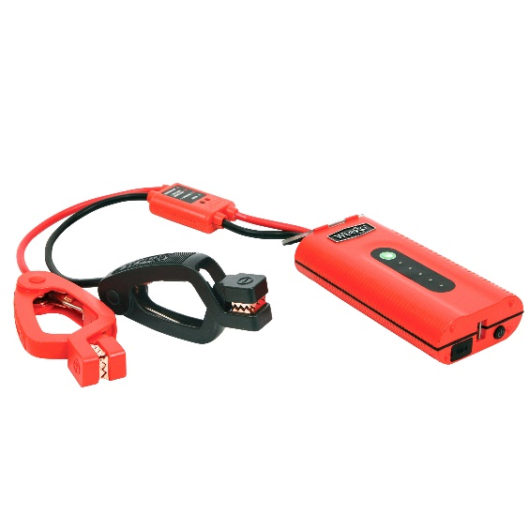
For more images, click HERE

Product Description:
There's a reason why Weego Jump Starter 44 is the "most popular" kid on the block. It's compact and super powerful. Not only will Weego 44 jump start gas engines up to 7L (and diesel up to 3.5L), it will also do way more: fast charge phones, tablets and laptops, power 12V accessories and light your way with an ultra-powerful, built-in flashlight. It's not just for emergencies; you can use it every day! Safe and simple, patented Smarty Clamps® ensure that you can't make a mistake. No experience required! Built to perform with durable, premium-quality components and an IP65 certification that means you can use it in surf and turf. Staying power? Get 1000 charging cycles and up to 3-years of standby power on a single charge. Award-winning, USA-designed and engineered, independently lab tested, verified specs (super important with portable jump starters), and hundreds of prestigious publication reviews are your assurance that Weego is the way to go!
- Starts car, truck, boat, motorcycle, ATV gas engines up to 7L (diesel up to 3.5L)
- Patented, foolproof Smarty Clamps® have comprehensive safety protections built in plus lights and sounds to guide you through a safe and simple jump every time
  - An extra-wide opening and power on both sides of the jaws guarantee a successful connection
  - Ergonomic grips and extra-long cables ensure easier access to hard-to-reach battery terminals
- Detect-o-Matic™ USB charging automatically provides fastest charge to your phones and tablets
- 12V and 19V outputs to power accessories and charge laptops
- 500-lumen LED flashlight illuminates up to 14-hours and strobe and SOS modes that last up to 28-hours on a single charge
- Hook and lanyard suspends Weego from a vehicle’s hood to light the engine below or to use as a camp or work light
- Surf ‘n turf approved - IP65 rated for water, dust and dirt resistance
- Up to 3-years of standby power - only loses 2% charge per month when stored!
- Offers over 1,000 full charging cycles
- Ideal operating temperature range from -4°F to 140°F
- Independent lab tested and backed by Crazy Long 18-month warranty

What’s in the Box (not really a “Box”. You’ll see):
- Battery pack
- Smarty Clamps®
- Wall & car chargers
- Hook & lanyard
- Water-resistant zippered pouch
- Tin collectible lunch box (sandwich not included)
- Owner’s manual
- Quick start guide

Specs:
Gas Engine Size: up to 7L
Diesel Engine Size: up to 3.5L
Battery Capacity: 41 Wh
Battery Type: Lithium-ion polymer
Voltage Compatibility: 12V only
Starting/Peak Current: 200A/400A
Max Input: 15V/1A
Recharge time: 3 hours at 15V/1A
Max Output USB: 5V, 9V or 12V/2.4A
USB Charging Port: 1
Max Output Access.: 12V/10A, 19V/3.5A
LED Indicator Lights: 5
Charging Cycles: 1,000 +
Operating Temp: -4°F to 140°F
Flashlight: 500 lumen dual LED: Flashlight, Strobe & SOS modes
Flashlight Duration: Flashlight mode: up to 14 hrs.
Strobe/SOS mode: up to 28 hrs.
Product Dims.: 6.5” L x 3.375” W x 1.5” H
Smarty Clamps® Length: 24”
Wire Gauge: 8 AWG
Packaging Dims.: 8.125” L x 3.75” W x 7.375” H
Packaged Weight: 3.5 lbs.
Warranty: 18-month

