Full Product Name: Weego Jump Starter 22s
Model Name: 22s
Model #: N22s

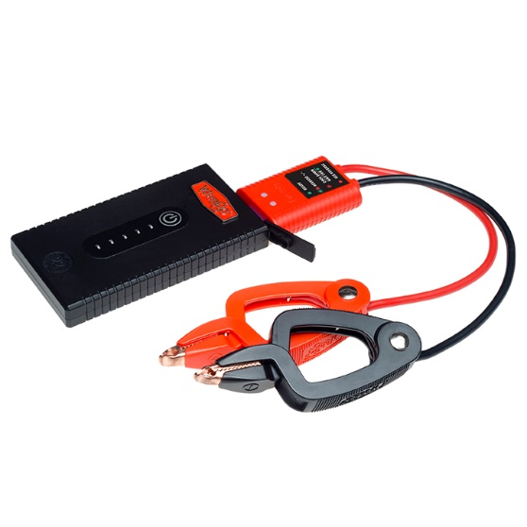
For more images, click HERE

Product Description:
Incredibly compact – no bigger than most cell phones - and affordable, Weego Jump Starter 22s can start motorcycles, boats and 95% of cars and trucks on the road today. Seriously! It can start vehicles with up to 5L gas engines and 2.5L diesel. And why is Weego 22s so affordable? We've stripped away the extras to provide a simple-to-use, jump-starting-only option that's still built to the same safe, premium-quality specifications as our other models. Weego 22s includes safe and simple, patented Smarty Clamps® to ensure that you can't make a mistake. No experience required! Staying power? Get 1000 charging cycles and over a year of standby power on a single charge. Award-winning, USA-designed and engineered, independently lab tested, verified specs (super important with portable jump starters), and hundreds of prestigious publication reviews are your assurance that Weego is the way to go!
- Starts car, truck, boat, motorcycle, ATV gas engines up to 5L (diesel up to 2.5L)
- Patented, foolproof Smarty Clamps® have comprehensive safety protections built in plus lights and sounds to guide you through a safe and simple jump every time
  - An extra-wide opening and power on both sides of the jaws guarantee a successful connection
  - Ergonomic grips and unique, tapered tips ensure easier access to hard-to-reach battery terminals
- Sealed ports for water, dust and dirt resistance
- Over a year of standby power on a single charge
- Offers over 1,000 full charging cycles
- Ideal operating temperature range from -4°F to 140°F
- Independent lab tested and backed by a Crazy Long 18-month warranty

What’s in the Box (not really a “Box”. You’ll see):
- Battery pack
- Smarty Clamps®
- Micro USB charging cord
- Carrying bag
- Tin collectible box
- Owner’s manual
- Quick start guide

Specs:
Gas Engine Size: up to 5L
Diesel Engine Size: up to 2.5L
Battery Capacity: 20 Wh
Battery Type: Lithium-ion polymer
Voltage Compatibility: 12V only
Starting/Peak Current: 150A/300A
Max Input: 5V/2A
Recharge time: 2.5 hours at 2.1A
LED Indicator Lights: 5
Charging Cycles: 1,000 +
Operating Temp: -4°F to 140°F
Product Dims.: 5.5” L x 3.0” W x 0.675” H
Smarty Clamps® Length: 18”
Wire Gauge: 10 AWG
Packaging Dims.: 7.875” L x 2.625” W x 6.25” H
Packaged Weight: 2 lbs.
Warranty: 18-month

