Full Product Name: Weego Jump Starter 22
Model Name: 22
Model #: N22

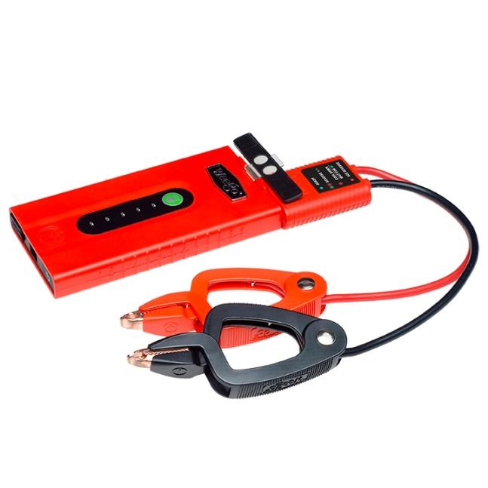
For more images, click HERE

Product Description:
Incredibly compact but loaded with power, Weego Jump Starter 22 can start motorcycles, boats and 95% of cars and trucks on the road today. Seriously! Easily and safely jump start vehicles with up to 5L gas engines and 2.5L diesel engines. No experience required! Not only will Weego 22 jump start, it will: fast charge phones, tablets and other USB devices, and light your way with a bright, built-in flashlight. It's small enough that you can literally use it every day! Safe and simple, patented Smarty Clamps® ensure that you can't make a mistake. Built to perform with durable, premium-quality components and an IP65 certification that means you can use Weego 22 in surf and turf. Staying power? Get 1000 charging cycles and over a year of standby power on a single charge. Award-winning, USA-designed and engineered, independently lab tested, verified specs (super important with portable jump starters), and hundreds of prestigious publication reviews are your assurance that Weego is the way to go!
- Starts car, truck, boat, motorcycle, ATV gas engines up to 5L (diesel up to 2.5L)
- Patented, foolproof Smarty Clamps® have comprehensive safety protections built in plus lights and sounds to guide you through a safe and simple jump every time
  - An extra-wide opening and power on both sides of the jaws guarantee a successful connection
  - Ergonomic grips and unique, tapered tips ensure easier access to hard-to-reach battery terminals
- Detect-o-Matic™ USB charging automatically provides fastest charge to your phones and tablets
- 250-lumen LED flashlight illuminates up to 7-hours and strobe and SOS modes last up to 14-hours on a single charge
- Hook and lanyard suspends Weego from a vehicle’s hood to light the engine below or to use as a camp or work light
- Surf ‘n turf approved - IP65 rated for water, dust and dirt resistance
- Over a year of standby power on a single charge
- Offers over 1,000 full charging cycles
- Ideal operating temperature range from -4°F to 140°F
- Independent lab tested and backed by Crazy Long 18-month warranty

What’s in the Box (not really a 'Box'. You'll see):
- Battery pack
- Smarty Clamps®
- Micro USB charging cord
- Car charger
- Hook & lanyard
- Carrying bag
- Tin collectible box
- Owner’s manual
- Quick start guide

Specs:
Gas Engine Size: up to 5L
Diesel Engine Size: up to 2.5L
Battery Capacity: 20 Wh
Battery Type: Lithium-ion polymer
Voltage Compatibility: 12V only
Starting/Peak Current: 150A/300A
Max Input: 5V/3A
Recharge time: 1.5 hours at 5V/3A
Max Output USB: 5V or 9V/2.4A
USB Charging Port: 1
LED Indicator Lights: 5
Charging Cycles: 1,000 +
Operating Temp: -4°F to 140°F
Flashlight: 250 lumen dual LED: Flashlight, Strobe & SOS modes
Flashlight Duration: Flashlight mode: up to 7 hrs.
Strobe/SOS mode: up to 14 hrs.
Product Dims.: 6.25” L x 3.175” W x 0.75” H
Smarty Clamps® Length: 18”
Wire Gauge: 10 AWG
Packaging Dims.: 7.875” L x 2.625” W x 6.25” H
Packaged Weight: 2 lbs.
Warranty: 18-month

